PHOTO SELECTION – GRID DRAWING
Instructions: (follow them carefully) (this is for a grade!)
- Find or take a portrait picture of Yourself, a family member, a friend, or someone you KNOW PERSONALLY, make sure it is a (head and shoulders picture, face is clearly visible) examples below.
- OR…. Find a picture of an idol, sports idol, musician, mom, film maker, politician, religious figure, sibling, friend, teacher???
- Do not use full body shots or pictures that have low resolution or are poor in quality
- If you do not have a picture I HAVE A CAMERA, PLEASE FEEL FREE TO USE IT!
- NOTE: Bettge has the final say in your picture decision. . . . .
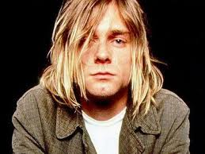
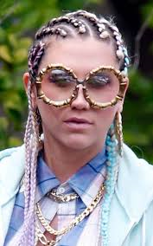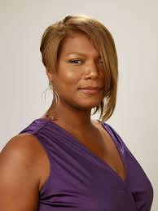
- Save this picture to your drive, desktop, or your device
- Name file as (your first initial, your last name, class period)
Example: Drew Bettge = dbettge5
- Email picture to Bettge as an attachment - dbettge@alvinisd.net
- Put in subject (first name , last name, period) Example: Drew Bettge 5th
- IF YOU DO NOT EMAIL ME A PICTURE PLEASE SEE BETTGE AT HIS DESK SO HE CAN PRINT THE PICTURE OF YOUR CHOICE!!!

