How to Make a Clay Whistle
Whistle in progress
The following is a step by step guide. See examples
Examples submitted by: Justin Kramer
Grades: 4-6

Resources:
How to make a clay whistle - with drawings of steps.
Making a Clay Whistle [Archive] - with photographs of steps. Here is Another source for the lesson [Archive] -
See some wonderful sculptural whistles from Whistle Press. [Archive]
Middle School Lesson Plan - Some examples (Scroll down. Archives)
Whistle While You Sculpt Crizmac video #2400 - $39.95 Featuring artist and teacher Paul Guion - 13 minute video program and Instructional Guide with reproducible student handout )step by step illustrations). (See instructional guide.)

Instructions

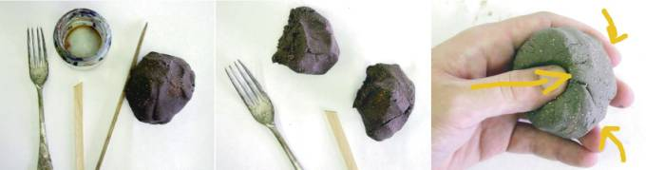
1. Equipment | 2. Separate clay into two small  balls | 3. Roll clay into ball. Push thumb into clay
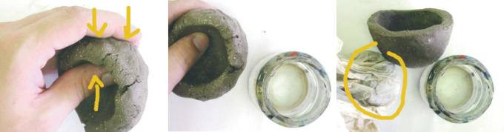
4. Pinch clay to form pinch pot | 5. Press until clay is even in  thickness | 6. Keep all unused clay covered
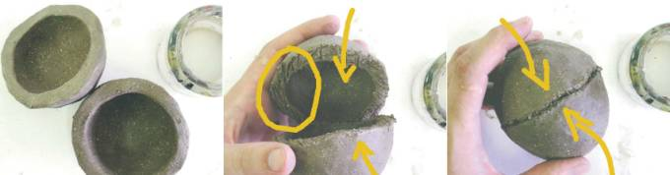
7. Make another pinch pot  same size | 8. Roughen both surfaces with fork  and add water or slip | 9. Force two halves together
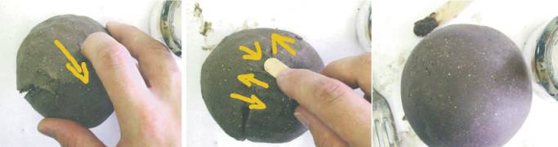
10. smooth over joints | 11. work clay back and forth  over joint | 12. smooth until no joint is visible
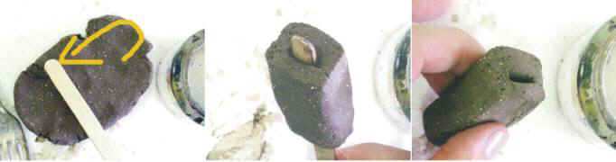
13. fold clay over paddle pop stick | 14. should be this thick | 15. remove stick from mouth piece
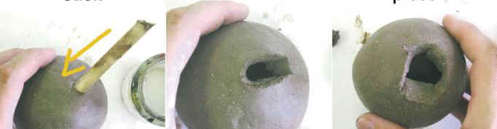
16. make hole with stick at angle (this will help make it work) | 17. remove clay to leave a wedge shape | 18. enlarge hole for mouth piece and clean up wedge shape
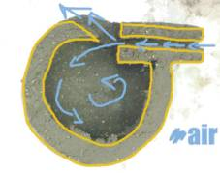 | 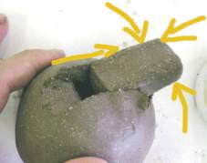 | 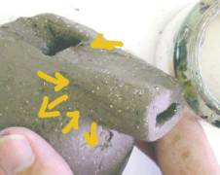
19. position the mouth piece so  air when passing through it will  be split by the clay wedge | 20. keep experimenting with the position of the mouth piece until maximum sound is achieved | 21. score, wet, join and smooth the mouth piece to the main body
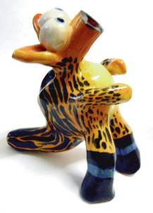 | 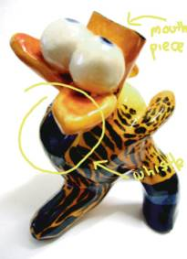 | 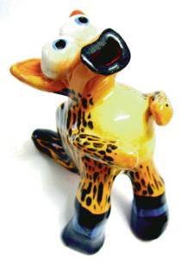
Submitted by: Justin Kramer KRAMER©2002
Alternate surface decoration:
Justin did a different spin on the surface decoration this year. Students emphasized the texture of the creatures through brushing with iron oxide (rubbed off surface to remain in textures). Once fired they then further coloured the forms with liquid inks. The works had a similar appears to hand coloured etchings.

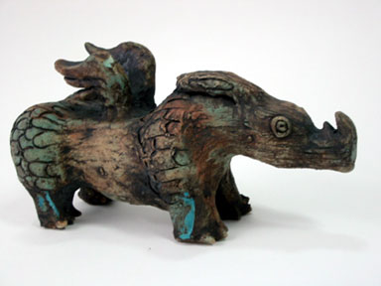 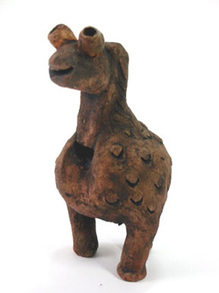 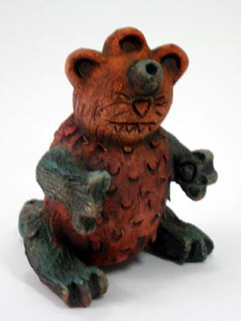
Click images to see larger views

Some advice from Justin:
We make two pinch pots, join them together, make a mouth piece using a piece of clay that is folded over a paddle pop stick. Use the same paddle pop stick to dig out a piece of clay from the joined pinch pots. When digging out the clay penetrate the clay ball at an angle as this will form the mechanics of the whistle. Position the mouth piece in varying positions adjusting proximity to the angle. Always look through the mouth piece to see that it isn't blocked and you can see the angled piece of clay in the middle. Once working, join it and then add all of your features.
The most interesting result about this activity is the students who get theirs working first. These students are the most unlikely and enjoy the position of being able to help others. The students find this activity very rewarding and always remember it as it presents a problem that requires them to understand the mechanics of a whistle in order to get it to work. In regards to health and safety - I tell the story that clay comes from the earth, the earth contains bacteria, germs and parasites - I conclude this by telling them that our clay is not sterilized....... don't put the clay to their mouth and wash their hands when they are finished. The easiest way to test the whistle is to wrap your hands around the mouth piece and blow onto your hand or hold the whistle in front of your mouth and not onto it.

See Justin's art room

Materials
- Moist Clay
- Popsicle sticks
- Glazes
Additional Tips from Michelle Kee
- Students hold their straight arms 45 degrees from their body to ensure they know what 45° looks/feels like. MS kids, what is - demo 90°, 45°, 60º deg? Hold the whistle horizontal to floor, hold popsicle stick 45° to hole.
- Creating wedge: stroke 45° with stick several times (especially if clay is fresh)
- Ensure the popsicle stick is a snug fit in the mouthpiece, slide it through for a clean passage.
- Aligning mouthpiece. Hold the whistle to the light source, look through the mouthpiece - you should see the ½ of the wedge and ½ of darkness = 100% success, blow. Reinforces lesson of splitting air to create sound.
- Make an extra whistle for the child who has tried several times, squished the clay the death and needs to move on...
Note from Judy D: All students should feel successful with this unit. Another way to have 100% success is to have students who "get it" go around and help those who are struggling.
- See more at: http://www.incredibleart.org/files/whistle.htm#sthash.jbCEjLZn.dpuf

